**Title:** Not all centromeres are equal, or are they?

**Authors:** Sarah N. Ruckman12+, Michelle Jonika13+, and Heath Blackmon123

1Department of Biology, Texas A&M University, College Station, Texas, USA

2Ecology and Evolutionary Biology Interdisciplinary Program, Texas A&M University, College Station, Texas, USA

3Genetics Interdisciplinary Program, Texas A&M University, College Station, Texas, USA

+Authors contributed equally and are co-first authors order was decided based on an R script simulating a coin toss

**Keywords:** Fusions, fissions, chromosome evolution, holocentric, monocentric

**Abstract**

Despite a century of research, many fundamental aspects of chromosome number evolution remain a mystery. One example is the dynamics of fissions and fusions in clades with holocentric or monocentric chromosomes. Holocentric chromosomes have centromeres that are diffuse and spindle fibers attach along the entire length of the chromosome, while monocentric chromosomes have a single, localized centromere. This difference in arrangement has led to the hypothesis that species with holocentric chromosomes can tolerate higher rates of fusions and fissions as compared to monocentric chromosomes, which may generate chromosomal fragments lacking centromeres that cannot segregate in monocentric species. To test for differences in the rates of fusions and fissions, we analyzed data from 12,412 species of insects in both a taxonomic and phylogenetic framework. Insects show a wide distribution of both type and number of chromosomes within their genomes and provide a good system to study chromosome number evolution. We found that clades with holocentric and monocentric chromosomes had similar rates of chromosome number evolution. When separated by order, we found significant differences in rates of fission, fusion and polyploidy among orders. Additionally, we find that the model used for inference (including or excluding polyploidy) had striking impacts on the estimated rates of fusions and fissions.

**Introduction**

Chromosome number stability is expected among lineages as shifts in chromosome number can lead to a decrease in fitness (Rieseberg 2001). This stability in chromosome number is driven by underdominance of chromosomal rearrangements (Rieseberg 2001). This characteristic has even been proposed as a possible driver of speciation (White 1969) . However, theoretical work has suggested that this stasipatric model of speciation may be unlikely (Lande 1984). Furthermore, empirical evidence suggests that many chromosomal rearrangements may have little or no fitness effect (Rieseberg 2001). More recently structural rearrangements have been proposed as a mechanism of speciation without the requirement for underdominance (Faria and Navarro 2010) (add citation to Reisberg 2010ish). In light of the possible role of chromosomal change in speciation identifying traits associated with increased rates of chromosomal rearrangements may explain patterns of extant diversity.

The evolution of chromosome number has been recalcitrant to the formation of rules or generalizations that can explain variation in patterns and rates across large clades. However, within clades, fusions and fissions are two of the dominant forces in reshaping karyotypes (Lucek 2018). We use these terms (fusion and fission) for simplicity to describe chromosome number changes of plus or minus one. However, in reality fusions decreasing chromosome number capture two different processes at the molecular level. First, Robertsonian translocations followed by the loss of the short arms can decrease chromosome number (Garagna *et al.* 1995). Second, fusion of telomeres from two chromosomes followed by inactivation of one of the centromeres can and has occurred in chromosome 2 in humans (Miga 2017). In contrast, changes increasing chromosome number can occur through simple fissioning in the centromere region and the gaining of new telomeric sequences (Moretti and Sabato 1984; Garagna *et al.* 1995). Increases in chromosome number can also occur through polyploidy or aneuploidy. In the case of polyploidy, an offspring can be produced from an unreduced gamete increasing by one the number of copies of the genome (Torres *et al.* 2008). Likewise, aneuploidy can lead to the duplication of single chromosomes (Torres *et al.* 2008).

Because chromosomal rearrangements are thought to be deleterious or underdominant they should only fix in populations with low effective population size or meiotic drive (CITE ME). However, centromeric structure may modulate the fitness effects of fusions and fissions. In species with monocentric chromosomes fusions and fissions can lead to multiple or no centromeres along the length of a chromosome which leads to failed segregation (CITATION). In contrast in holocentric species the centromeres are diffuse and spindle fibers attach along the entire length of the chromosome. In these species fusions and fissions do not appear to disrupt proper segregation (Malheiros-Garde and Gardé 1950; Faulkner 1972; Cope 1985; Luceño and Guerra 1996). Therefore, holocentricity has the potential to reduce or eliminate selective pressure against chromosomal rearrangements. This should lead to higher rates of chromosome number evolution in clades with holocentric chromosomes relative to clades with monocentric chromosomes (Escudero *et al.* 2012).

If holocentric clades have higher rates of chromosome evolution, we might expect holocentric species to exhibit higher chromosome number. Anecdotal evidence does seem to suggest that some of the highest chromosome numbers observed are in clades with holocentric chromosomes. For instance, in insect the highest chromosome numbers are observed in the holocentric lepidoptera (Blackman 1980). However, initial analyses have found no significant difference in chromosome number among holocentric and monocentric clades of insects (Blackmon *et al.* 2017). This previous study was limited to an order level analysis and looked only for an absolute difference in chromosome number between monocentric and holocentric clades. A stronger test of the impact of holocentricity would be to investigate the rates of fusions, fissions in clades with holocentric and monocentric chromosomes.

In this study, we used chromosome number and centromere type for 599 insects to test whether clades with holocentric chromosomes have a higher rate of fusions and fissions than clades with monocentric chromosomes (Figure 1). We chose to use insects because they have multiple clades with monocentric and holocentric chromosomes, are incredibly speciose, and exhibit striking diversity in chromosome number (Cook 2000; Mora *et al.* 2011; Ross *et al.* 2015; Blackmon *et al.* 2017; Vershinina and Lukhtanov 2017). Our hypothesis is that clades with holocentric chromosomes will exhibit higher rates of fusions and fissions since these mutations should be less costly in these clades.

**Methods**

*Data collection:* We downloaded all available chromosome data for insects from a prior study (Blackmon *et al.* 2017). This dataset is composed of 12,412 species comprising 376 families and 3,872 genera. The minimum haploid chromosome number is 2 while the maximum chromosome number is 141. There are 3,465 species with holocentric chromosomes and 8,946 species with monocentric chromosomes. This paper also included classification for each order into either monocentric or holocentric. From this dataset we extracted the homogametic haploid chromosome number for each of the species. We used genus level phylogenies from a previous study that contained 1,726 tips (Church *et al.* 2019). We downloaded two samples from posterior distributions based on different backbone trees. These trees were used for all downstream comparative analyses. Our trait data set had an overlap of 599 genera with the phylogenetic data (Figure 1). In cases where we had multiple samples we retained all records for a genus.

*Comparative analyses:*We fit a model of chromosome evolution on each tree from the posterior distribution. This model can accommodate up to eight rates: rate of chromosome number increase (fissions γ), rate of chromosome number decrease (fusions δ), rate of whole genome duplication (polyploidy ρ) each of these is estimated separately for clades with holocentric and monocentric chromsomes leading to six chromosomal rate parameters. The final two parameters describe the transition to and from monocentric and holocentric (qMH and qHM).

This model was specified using the R package chromePlus (Blackmon *et al.* 2019) and was fit using Bayesian approach in the R package diversitree (Fitzjohn).

on each tree from the posterior distribution and we randomly sample trait data when more than one species is available for a genus. This approach allows us to account for uncertainty in the phylogeny and tip states.

We repeated similar analysis as above for the analysis of orders, however we ran the data twice. Once with polyploidy and once without polyploidy included in the model. We only included orders with more than 20 genera in the analysis, limiting our analyses to 10 orders. This was to ensure that we had a large enough sample size as well as enough time along the branches to determine the rates of chromosome evolution. In total, we used ten orders for our analysis. Three of which had holocentric chromosomes, and seven that had monocentric chromosomes. The three orders with holocentric chromosomes were Hemiptera, Lepidoptera, and Odonata. We used the same prior as above from an exponential distribution with a shape parameter of 0.5 and initialized our MCMC with parameter values drawn from a uniform distribution from either 0-2 or 3 depending on if we included polyploidy in our analysis. We repeated the MCMC with all 100 trees at 50 generations each. We removed the first twenty-five samples as our burnin for each run.

**Results**

*Rates of Chromosome Number Evolution Across Orders*

First, we wanted to assess differences in the rate of chromosome number evolution across insect orders. Rates of chromosome number were inferred for each of the 10 orders. Three orders are holocentric (Hemiptera, Lepidoptera, Odonata) while the other 7 are holocentric (Blattodea, Coleoptera, Diptera, Hymenoptera, Isoptera, Neuroptera, and Phasmatodea). Our analysis of the data described with ascending and descending rates of chromosome number evolution alone showed some variability, with Phasmatodea and Lepidoptera having the most variance (Figure 2a). Despite this variability, there appears to be no pattern in those clades with high rates of chromosome number evolution and either monocentric or holocentric chromosomes. This indicates differences among orders, but no relationship between holocentricity and rates of chromosome number evolution.

With the addition of polyploidy into the model, the variance among rates of chromosome number evolution is reduced among the orders (Figure 3b). Despite this, the descending rate was higher in Blattodea, Isoptera, and Phasmatodea. This is representative of some, but not all monocentric orders. The order Lepidoptera shows a decrease in ascending and descending rates of chromosome number evolution with the addition of polyploid into the model. This is most likely driven by large variation in chromosome number associated with the order.

*Analysis of Monocentric and Holocentric Species*

Next, we wanted to assess the effects of holocentric and monocentric chromosomes on the rates of chromosome number evolution. Rates of ascending, descending, and polyploidy were inferred for orders with holocentric and monocentric chromosomes. For these three rates, These parameters included fusion, fission, and the transition between monocentric and holocentric chromosomes and vice versa. The data had low variability and the rates did not show a difference between monocentric and holocentric chromosomes (Figure 2). This indicates that there are no significant differences among rates of chromosome evolution based on type of chromosome.

**Discussion**

The hypothesis that holocentric chromosomes are more tolerant to fusions and fissions and therefore have a higher rate of chromosome evolution was not supported by our data. Overall, the rates of chromosome evolution were similar among monocentric and holocentric species. When our data was separated based on orders, the rates showed differences among orders and not due to differences in chromosome type. This is most likely due differences amongst orders based on different selective pressures experienced by the clades rather than the type of chromosome. Holocentric chromosomes may be more tolerant to fusions and fissions. However, chromosome number is constrained by external factors that have not caused a difference in the rate of chromosome evolution due to holocentricity alone.

**Figures:**

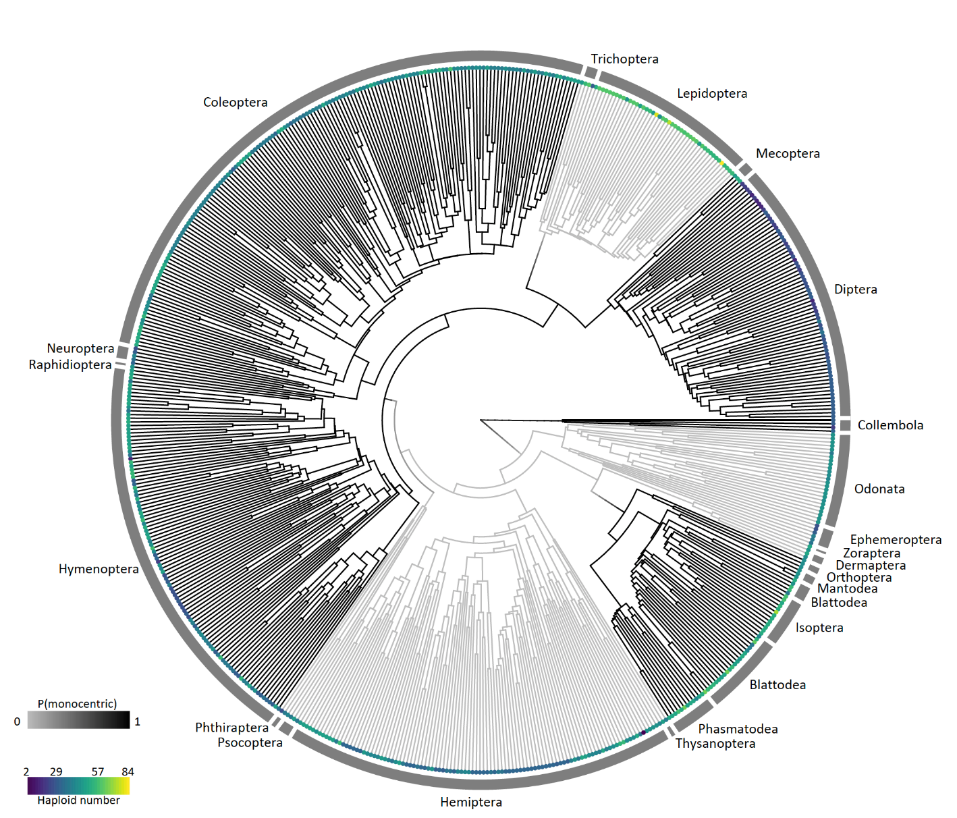

**Figure 1: Phylogeny of type of centromeres and chromosome number.** The black branches represent orders with monocentric chromosomes and the gray branches represent orders with holocentric chromosomes. The colored circles at the tips represents the haploid chromosome number the color scale is log transformed to allow better visualization of variation in species with low chromosome number.

**Figure 2: Rates of chromosome evolution.**



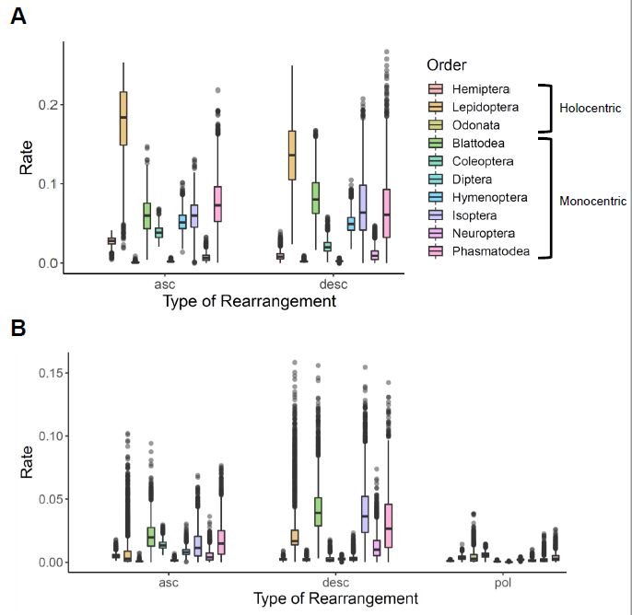

**Figure 3:** **Rate of chromosome evolution based on order**. Ascending rates represent the rate of fissions, descending rates represent the rate of fusions, and pol rates represent the rate of polyploidy. (A) Modelling for rates of chromosome evolution with polyploidy. The addition of polyploidy in the model has decreased the variation of all rates of chromosome evolution. There is no trend between holocentric and monocentric chromosome orders. (B) Modelling for the rates of chromosome evolution without polyploidy. The removal of polyploidy has kept most of the other species at about the same rates of chromosome evolution, expect for Lepidoptera. Lepidoptera has an increase in both fusion and fission rates.

**References**

Blackman, R. L., 1980 Chromosomes and parthenogenesis in aphids, pp. 133-148 in *Insect cytogenetics, 10th Symposium of the Royal Entomological Society. Blackwell Scientifi Publ, Oxford*.

Blackmon, H., J. Justison, I. Mayrose and E. E. Goldberg, 2019 Meiotic drive shapes rates of karyotype evolution in mammals. Evolution 73**:** 511-523.

Blackmon, H., L. Ross and D. Bachtrog, 2017 Sex Determination, Sex Chromosomes, and Karyotype Evolution in Insects. Journal of Heredity 108**:** 78-93.

Brown, K. S., T. C. Emmel, P. J. Eliazar and E. Suomalainen, 1992 Evolutionary patterns in chromosome numbers in neotropical Lepidoptera: I. Chromosomes of the Heliconiini (Family Nymphalidae: Subfamily Nymphalinae). Hereditas 117**:** 109-125.

Church, S. H., S. Donoughe, B. A. de Medeiros and C. G. Extavour, 2019 Insect egg size and shape evolve with ecology but not developmental rate. Nature 571**:** 58-62.

Cook, L. G., 2000 Extraordinary and extensive karyotypic variation: a 48-fold range in chromosome number in the gall-inducing scale insect Apiomorpha (Hemiptera: Coccoidea: Eriococcidae). Genome 43**:** 255-263.

Cope, T., 1985 Cytology and hybridization in the Juncus bufonius L. aggregate in western Europe, pp. in *Watsonia*. Citeseer.

Emmel, T., P. Eliazar, K. Brown Jr and E. Suomalainen, 1995 Chromosome evolution in the Papilionidae. Swallowtail butterflies: their ecology and evolution. Scientific Publishers, Gainesville**:** 283-298.

Escudero, M., A. L. Hipp, T. F. Hansen, K. L. Voje and M. Luceño, 2012 Selection and inertia in the evolution of holocentric chromosomes in sedges (Carex, Cyperaceae). New Phytologist 195**:** 237-247.

Faria, R., and A. Navarro, 2010 Chromosomal speciation revisited: rearranging theory with pieces of evidence. Trends in ecology & evolution 25**:** 660-669.

Faulkner, J., 1972 Chromosome studies on Carex section Acutae in north-west Europe. Botanical Journal of the Linnean Society 65**:** 271-301.

Garagna, S., D. Broccoli, C. A. Redi, J. B. Searle, H. J. Cooke *et al.*, 1995 Robertsonian metacentrics of the house mouse lose telomeric sequences but retain some minor satellite DNA in the pericentromeric area. Chromosoma 103**:** 685-692.

Lande, R., 1984 The expected fixation rate of chromosomal inversions. Evolution**:** 743-752.

Lucek, K., 2018 Evolutionary mechanisms of varying chromosome numbers in the radiation of Erebia butterflies. Genes 9**:** 166.

Luceño, M., and M. Guerra, 1996 Numerical variations in species exhibiting holocentric chromosomes: a nomenclatural proposal. Caryologia 49**:** 301-309.

Malheiros-Garde, N., and A. Gardé, 1950 Fragmentation as a possible evolutionary process in the genus Luzula DC. Genetica Iberica 2**:** 257-262.

Miga, K. H., 2017 Chromosome-specific centromere sequences provide an estimate of the ancestral chromosome 2 fusion event in hominin genomes. Journal of Heredity 108**:** 45-52.

Mora, C., D. P. Tittensor, S. Adl, A. G. Simpson and B. Worm, 2011 How many species are there on Earth and in the ocean? PLoS biology 9.

Moretti, A., and S. Sabato, 1984 Karyotype evolution by centromeric fission inZamia (Cycadales). Plant Systematics and Evolution 146**:** 215-223.

Papeschi, A., 1988 C-banding and DNA content in three species of Belostoma (Heteroptera) with large differences in chromosome size and number. Genetica 76**:** 43-51.

Papeschi, A., 1991 DNA content and heterochromatin variation in species of Belostoma (Heteroptera, Belostomatidae). Hereditas 115**:** 109-114.

Rieseberg, L. H., 2001 Chromosomal rearrangements and speciation. Trends in ecology & evolution 16**:** 351-358.

Robinson, R., 2017 *Lepidoptera Genetics: International Series of Monographs in Pure and Applied Biology: Zoology*. Elsevier.

Ross, L., H. Blackmon, P. Lorite, V. E. Gokhman and N. B. Hardy, 2015 Recombination, chromosome number and eusociality in the Hymenoptera. Journal of evolutionary biology 28**:** 105-116.

Sunnucks, P., P. R. England, A. C. Taylor and D. F. Hales, 1996 Microsatellite and chromosome evolution of parthenogenetic Sitobion aphids in Australia. Genetics 144**:** 747-756.

Torres, E. M., B. R. Williams and A. Amon, 2008 Aneuploidy: cells losing their balance. Genetics 179**:** 737-746.

Vershinina, A. O., and V. A. Lukhtanov, 2017 Evolutionary mechanisms of runaway chromosome number change in Agrodiaetus butterflies. Scientific reports 7**:** 1-9.

White, M., 1969 Chromosomal rearrangements and speciation in animals. Annual review of genetics 3**:** 75-98.

White, M. J. D., 1977 *Animal cytology and evolution*. CUP Archive.

Wolf, K. W., K. Novák and F. Marec, 1997 Kinetic organization of metaphase I bivalents in spermatogenesis of Lepidoptera and Trichoptera species with small chromosome numbers. Heredity 79**:** 135-143.

**SNIPPETS**

the range of chromosome numbers in holocentric species does not appear remarkably different from those species with monocentric chromosomes. Although tolerance in fragmentation of chromosomes has been observed for some species with holocentric chromosomes, this evolution does not appear to lead to excessive ranges in chromosome number for many species (White 1977; Blackman 1980; Papeschi 1988; Papeschi 1991; Brown *et al.* 1992; Sunnucks *et al.* 1996).

An example of this is the order Lepidoptera, a group with holocentric chromosomes that contains large diversity in chromosome number (Wolf *et al.* 1997). While a few species seem to be tolerant to chromosomal rearrangements (Brown *et al.* 1992; Robinson 2017), many species exhibit little variation in chromosome number (White 1977; Emmel *et al.* 1995; Robinson 2017).